Web Lab: 3

Name: Nisha
Section: F
CMS id: 023-24-0178


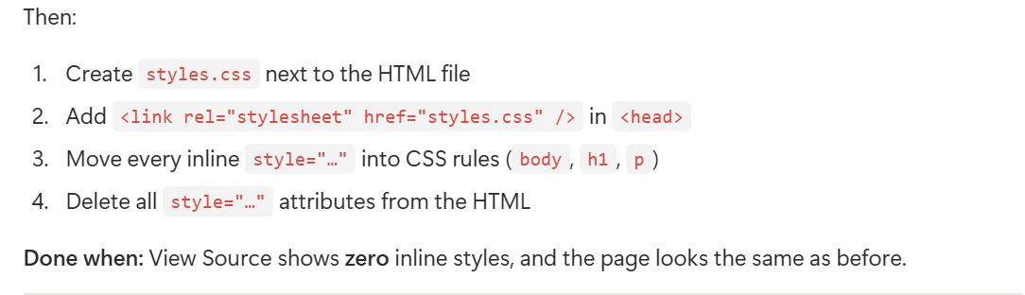
<!-- inline-start.html -->
<!DOCTYPE html>
<html lang="en">
<head>
<meta charset="UTF-8"/>
<meta name="viewport" content="width=device-width, initial-scale=1.0"/>
<title>Inline to External</title>
<link rel="stylesheet" href="styles.css"/>
</head>
<body>
<h1>My Profile</h1>
<p>
I am learning web engineering this semester.
</p>
<p>
I like coffee, walking, and building small websites.
</p>
</body>
</html>
/* styles.css */
body {
background: #f4f1ea;
font-family: Georgia, serif;
}

h1 {
color: navy;
font-size: 2rem;
}

p {
color: #333;
font-size: 1.125rem;
line-height: 1.6;
}
Output:
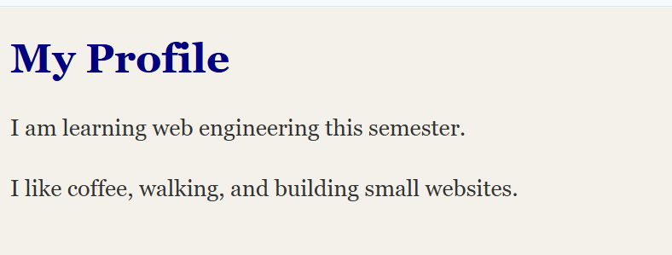
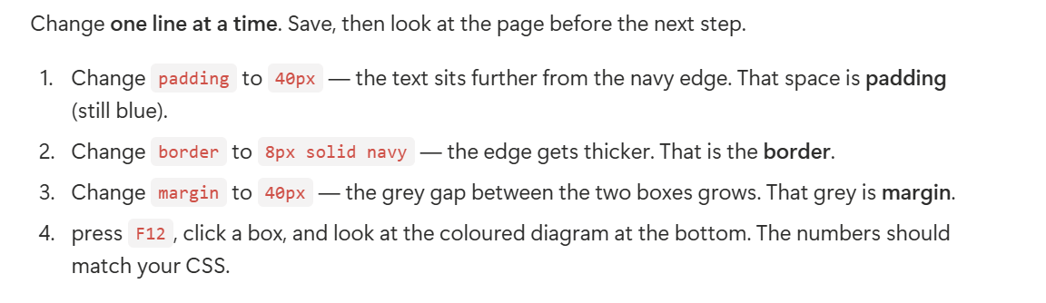
<!DOCTYPE html>
<html lang="en">
<head>
<meta charset="UTF-8">
<meta name="viewport" content="width=device-width, initial-scale=1.0">
<title>CSS Box Model</title>
<link rel="stylesheet" href="styles.css">
</head>

<body>
<div class="box">Box 1 — this text is the content.</div>
<div class="box">Box 2 — watch the gap between us.</div>
</body>
</html>
body {
background: #e8e8e8;
}

.box {
width: 280px;
padding: 40px;
border: 8px solid navy;
margin: 40px;
background: #e3f2fd;
}
Output:
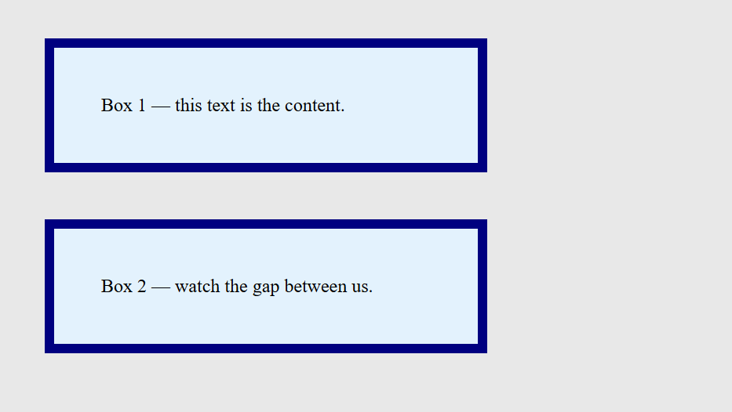


<!DOCTYPE html>
<html lang="en">
<head>
<meta charset="UTF-8">
<meta name="viewport" content="width=device-width, initial-scale=1.0">
<title>Selector Scavenger Hunt</title>
<link rel="stylesheet" href="styles.css">
</head>

<body>
<h1>Selector hunt</h1>

<p>This is a normal paragraph.</p>
<p class="note">This paragraph has a class.</p>
<p id="alert">This paragraph has an id.</p>

<ul>
<li>HTML</li>
<li>CSS</li>
<li>Git</li>
<li>JavaScript</li>
</ul>

<nav>
<a href="#skills">Skills</a>
<a href="#about">About</a>
</nav>

<input type="email" placeholder="email input"/>
<input type="text" placeholder="text input"/>
</body>
</html>

h1 {
color: navy;
font-size: 2rem;
}

.note {
color: teal;
font-weight: bold;
}

#alert {
background: #fff3cd;
padding: 8px;
}

input[type="email"] {
border: 2px solid teal;
padding: 8px;
}

a:hover {
color: crimson;
text-decoration: underline;
}

li:nth-child(odd) {
background: #e3f2fd;
}

li:nth-child(even) {
background: #fff3e0;
}
Output:
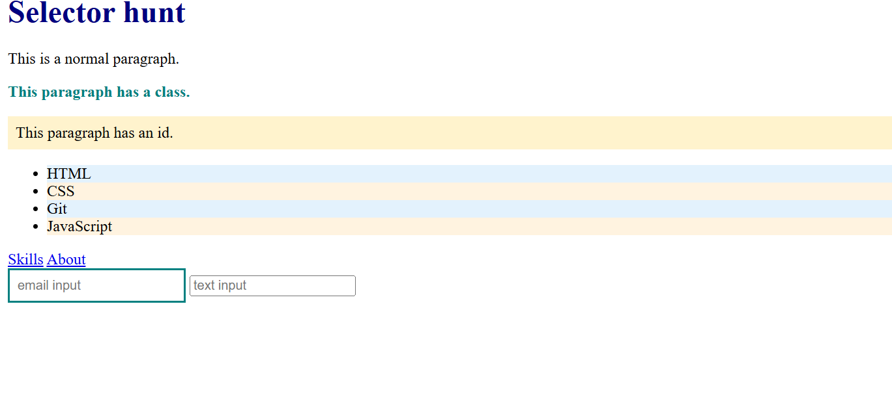


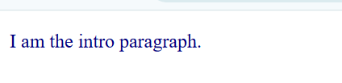
Explanation:
The #main p rule wins because its specificity is 1,0,1, which is higher than .intro (0,1,0), p.intro (0,1,1), and p (0,0,1). Therefore, the paragraph appears navy.

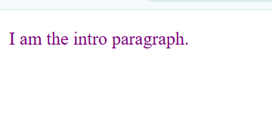
Explanation:
The p.intro rule wins because its specificity is 0,1,1, which is higher than .intro (0,1,0) and p (0,0,1). Therefore, the paragraph appears purple.

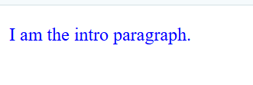
Explanation:
The .intro rule wins because its specificity is 0,1,0, which is higher than the p selector (0,0,1). Therefore, the paragraph appears blue.

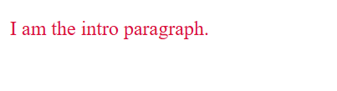
Explanation:
Both rules have the same specificity: 0,0,1. When specificity is equal, the last rule wins, so the paragraph appears crimson.


Explanation:
The inline style wins because inline styles have higher priority than normal author stylesheet rules. Therefore, the paragraph appears hotpink.

